

IRENE GUISER
Singer - Actress

Pantaleón Rivarola 2462

(1417) Bs As - ARGENTINA
Tel/Fax: (54 11) 4502- 8177
irene@viajesinfin.com

TRABAJOS REALIZADOS

2006/2002: Cantante del Espectáculo “PAISAJES ARGENTINOS, Tango & Folklore” en:
Grand Valley State University y Acquinas College (Michigan) / Augustana College
(Rock Island)/ Kutztown University (Pennsylvania) / USA

2006/ 2000: Directora Musical de DISNEY LATINOAMÉRICA, y de los Estudios
Palmera Record e Imágen Satelital / Buenos Aires-ARGENTINA

2005 /1993: Doblaje al castellano de Películas, Documentales y Dibujos Animados para Cine y T.V.
(Discovery Channel, National Geographic, Animal Planet, Peoples and Arts, I-Sat, Canal 13, Telefe, Canal9, Canal 7, etc.)
Estudios: DISNEY Latinoamérica- Palmera Record- Video Record- Video Dub - Civisa - Imagen Satelital / Buenos Aires
Voces de: Meg Ryan- Meryl Streep- Darryl Hanna-Juliette Binoche- Isabel Adjani- Gwynette Paltrow- Catherine Deneuve- etc.

2004/2003: Canciones , Voces y Narración de Cuentos Infantiles Clásicos
Colección “Huellitas”/ Editorial Arquetipo COLOMBIA, MÉXICO y URUGUAY

2002: Cantante invitada por el Guitarrista ESTEBAN MORGADO para el
Ciclo “Los 36 Billares” / Buenos Aires

2002/2001: Actriz de “SUBTEMAN”, Serie de Cortos de Humor emitida a través
del Canal SubTV / Buenos Aires

2001: Cantante invitada al FESTIVAL NACIONAL de COSQUÍN,
Escenario“Atahualpa Yupanqui” /Pcia. de Córdoba-ARGENTINA

2001/1994: Grabación de jingles y publicidades para Radio y T.V.
ARGENTINA, CHILE, URUGUAY y MÉXICO

1997: Gira por BRASIL. Espectáculo de Tango con la Orquesta del Maestro
Jorge Dragone. Dirección: Bailarines Roberto Herrera y Vanina Bilous.

1990/1989: Gira por Islas Canarias - ESPAÑA / Cuarteto “Travesía”

1988: Grabación del 1º Larga Duración “IRENE GUISER, Así Como Suena”
Arreglos y Dirección de LITO VITALE, MICROFON / ARGENTINA

1988/1987: Integrante del elenco de:“CECILIA ROSETTO”, In Concerto”.
Teatro Bambalinas - Teatro Fundart / Buenos Aires
Temporada de Verano en Villa Carlos Paz / Córdoba
Actuaciones en Viña del Mar y Santiago de Chile / CHILE

1986: Representante Argentina en el Festival de la Nueva Canción
en Asunción / PARAGUAY

1985: Animadora del Programa Infantil de Televisión “Muchas Cosas” ( A.T.C. ) / Buenos Aires

1984: Cantante invitada del “Luis Borda Sexteto” y del guitarrista
Hugo Romero / Buenos Aires y Rosario

1984/1977: Integrante del Grupo Vocal e Instrumental “Quintral”.
Actuaciones en ARGENTINA y Gira por ALEMANIA, HOLANDA y UNIÓN SOVIÉTICA.

ESTUDIOS CURSADOS

Secundarios: Bachiller, Colegio Nacional Buenos Aires

Terciarios: Profesora de Jardín de Infantes, Colegio Normal, Estados Unidos de América

Universitarios: Musicoterapeuta, Universidad del Salvador

Musicales: Violin: Alejandro Elijovich / Szymsia Bajour
Audioperceptiva: Luis María Corallini
Canto: Mario Barabini / Patricia Andrade

Actorales: Teatro: Victor Bruno / Idelma Nudel
Seminario de Clown: Marcelo Katz
Actuación en cine: Jorge Coscia/ Guillermo Saura

Danza: Danza Contemporánea: Estudio Margarita Bali
Tango: Vanina Bilous- Roberto Herrera

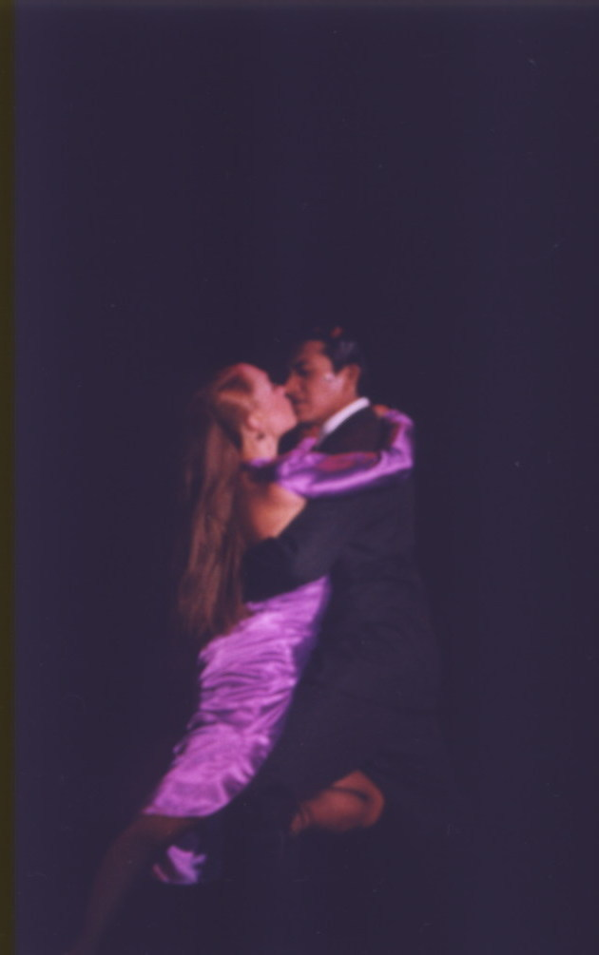
Cristian & Virginia
TANGO & FOLKLORE DANCE

Virginia Laura Porrino
And
Cristian Rodolfo Cisneros
Av. Corrientes 2555 5° "1"
Phone: (54 11) 4952-2924
crisvirtango@hotmail.com

Tango Studies With The Following Professors

Vanina Bilous and Roberto Herrera
Héctor Falcón and Susana Rojo
Pepito Avellaneda
Carlos Copello
Judit and Fernando Jiménez
Alejandra and Omar Cáseres
Ezequiel Falfaro

Folklore Studies With The Following Professors

Marina and Hugo Jiménez (and other members of the Ballet of Salta)

International Performances

2005/06 HOLANDA, TURQUÍA y POLONIA
(con laCompañía “Tango Seducción”, de Gustavo Russo)

2004 ESTONIA , Tallin (con la Compañía “Tango Seducción”)
MARTINIQUE , 33 Festival de Música y Danza de Fort de
France (Cía. “Tango Seducción”)
LITUANIA- ISRAEL- FRANCIA (Teatro Olimpia de PARIS)
BRASIL , San Pablo (Espectáculo “La Ventana” Tango Show)

2003 CHINA , Taiwán - Taipei (Cía. “Tango Seducción”)
USA , Michigan (Grand Valley State University y Acquinas
College) – Rock Island (Augustana College)/ Espectáculo:
“Paisajes Argentinos” y dictando Clases de Tango
USA , Orlando - Florida ( Show en Mega Fiesta Privada)
CHILE , Concepción (Teatro Municipal) - Santiago(Teleton)-
Valparaiso(Teatro Municipal) / Espectáculo “Taconeando”
TURQUÍA- AUSTRIA- GRECIA (Cía. “Tango Seducción”)
ECUADOR, Quito (Hillton Hotel) - Guayaquil (Swiss Hotel)

2002 RUSSIA (Moscu - Saint Petersburg).
USA (Kutztown, Pennsylvania: The Shaeffer Auditorium - Kutztown University) ISRAEL (Tel Aviv).

2001 NORWAY (Oslo).
CHINA (Makaus).

1999 JAPAN (Tokio – Toshima – Shinjyuku – Nigata – Yokohama – Sendai Matsumoto – Osaka –
Nagoya – Koriyama: A Tour with Beba Puliese Orchestra and the Dancers Vanina Bilous and
Roberto Herrera).
USA (Atlanta, Georgia: Event sponsored by LAPA Airlines during its inuagural flight to the
United States).

1998 USA
* Washington D.C. (Liner Auditorium - George Washington University)
* Baltimore ( Morris A .Mechanic Theater ).
* Palm Beach - Miami Beach (Duncan Theater University).
ECUADOR, Quito - Guayaquil (Eduardo Espejo Theater - Art Center).

1997 USA Palm Beach - Miami Beach (Duncan Theater University).

1996 BRAZIL (Santos - Río de Janeiro - Bahía - Angra Dos Reis: "Turbonave Monterrey" Cruise).

1996-95 BRAZIL (Porto Alegre: First/Second Encounter of Mercosur).

1995 ISRAEL (Jerusalem - Tel Aviv - Nazareth - Haifa - Tiberia: International Festival on behalf of The Republic of Argentina).
SPAIN (Bilbao: Casa Vaska / Oboe).

Local Performances

Sceneries:
El Querandí
La Ventana
Sabor a Tango
Café Tortoni
La Dama de Bollini
La Cumparsita
El Mangrullo
La Vizcachera (Mar del Plata)
Rodizzio
Clo-Cló
Social Rivadavia
World Tango (Ushuaia), etc.

Theaters:

Lola Membrives
Centro Cultural Borges (Homenaje a Osvaldo Pugliese, con la “Orquesta de Beba Pugliese”)
Teatro Nacional Cervantes (First National Tango Encounter, with Juan de Dios Filiberto Orchestra, directed by Osvaldo Piro)
Auditorio del Colegio de Abogados(“Orquesta de Roberto Firpo”)
Teatro Astral
Teatro Presidente Alvear
Teatro de la Ribera
Teatro Auditorium (1998 International Film Festival, Mar del Plata).
Complejo La Plaza
Teatro Coliseo Podestá (La Plata),
Teatro Luz y Fuerza, etc.

Other Places:
Residencia Presidencial de Olivos
Congreso de la Nación (Salón de los pasos perdidos)
Secretaría de Cultura de la Nación (Sala Miguel Cané)

Sociedad Rural Argentina
Luna Park
Feria del Libro
Polideportivo Municipal de Mar del Plata
Festejos en conmemoración por 50 Aniversario de la República Popular de China (Plaza de las Naciones).
Auditorio del Colegio de Abogados (with Roberto Firpo Orchestra).
Restaurantes de Tango Show (“La Ventana”, “El Querandí”, “Sabor a Tango”, “Café Tortoni”, “La Cumparsita, etc.)

Hotels:
Park Hyath
Mansión Álzaga Unzué (Park Hyatt)
Sherathon Hotel
Hotel Intercontinental
Alvear Palace Hotel, etc.

Residential Mansions:
Hebraica
Aranjuez
Los Cardales, etc.

Argentine T.V. Channels

A.T.C. (La noche con amigos) (El gran debut)

América 2 (Argentinísima)

Technical Rider for
PAISAJES ARGENTINOS

General Information

- Our Artistic Director will contact the on-site technical person approximately 2 weeks before the performance. Please provide this individuals name and any contact information (i.e. regular phone number, cell phone number and email address) with signed contract.
- The performance is approximately one and a half hours with no intermission.
- We will need at least two dressing rooms close to the stage with mirrors.
Sanitary toilet facilities with hot and cold running water must be provided for the male and female cast members. These restrooms should be separate from those provided for the audience.
- The taking of pictures during the performance is not allowed, nor is the video or
sound recording of the show, without the expressed permission of Paisajes Argentinos.
- Company needs the uninterrupted use of the theatre for a minimum of 6 hours
prior to performance. This is for an 8pm performance. Please adjust for other curtain times.

Personnel

There needs to be someone available at all times to answer technical questions.
- We will require the following positions to be staffed for the performance.
  - House lights/Stage Manager
  - Lighting Director
  - Sound Engineer
  - Video Engineer ( The playback unit must be located in the same place as the sound control, so this position may be included in the other job titles listed)
  - Followspot operator(s) (optional)

Sound

- Sound system should be appropriate to the size of the venue and of sufficient fidelity for the presentation of live music and spoken word.
- One professional quality CD player
- Two vocal microphones (SM 58 or equiv.) and four instrument microphones (sm57 or equiv). Six boom stands.
- One stage monitor for vocalist and at least two monitors to cover performance
area for dancers and musicians. The dancer monitors ideally should be positioned as sidefill and in wing one. One monitor mix is sufficient, but should have eq available for adjustments independent of house sound.
- Please provide one piano for the performance.

Technical Rider for
PAISAJES ARGENTINOS

Lighting

These are suggested guidelines for the lighting of Paisajes Argentinos. Please use your judgement in creating a varied and colorful performance area. We are open to any other ideas that you may wish to suggest.
- Front DSR special (R33) for moderator.
- Front DSL area for vocalist. (R34)
- Front light wash for dance performance area (30w x 20 d) (R34 or L109)
- High side or back light washes for dance performance area. (suggestions R42, L180,R22,R79)
- Pattern group to screen (optional)
- Floor specials or ground rows to screen (optional)
- Sidelight booms (optional)
The company understands that many theatres have very busy schedules and cannot hang a specific plot for our show. Use any existing lighting plot that is available and adapt it to the suggested guidelines. The music and dance presented is very evocative and visual. Use your lighting design talent to create as lush a performance area as possible.

Video

The group uses a video screen as a backdrop to the performance. There are two points in the presentation where video is shown. The screen should be positioned far enough upstage to allow a performance area (30’w x 20’ d) for the dancers.

- The screen size should be a minimum of 9’ x 12’. It can either be flown from the house pipes or supported from the ground.
Please note: Classroom style tripod screens are not acceptable.
- The screen should be masked as appropriate and ideally played against a black backdrop.
- Either front screen or rear screen projection is acceptable. Please insure that the image size fills as much of the screen as possible.
4) The projector type is at the discretion of the Technical Director. It should
should have sufficient brightness (lumens) to allow the subject material
to be clearly viewed.
5) The required playback system is professional Betacam format (NTSC).

Other

- Please provide communication to all technical locations as well as SR and SL.
- Please provide 2 café style round tables as well as 4 café style chairs (those are necessary on stage for one scene during the show).

